**FSD ASSIGNMENT 01**

**Exercise 1: Basic HTML5 Structure**

<html lang="en">

<head>

    <meta charset="UTF-8">

    <meta name="viewport" content="width=device-width, initial-scale=1.0">

    <title>My First HTML Page</title>

</head>

<body>

    <h1>Md Talha Asif</h1>

    <p>I enjoy watching cricket. I also like playing chess and listening to music.</p>

    <hr> horizantal line

    <br>

    <br> Line Break

</body>

</html>

**Output**

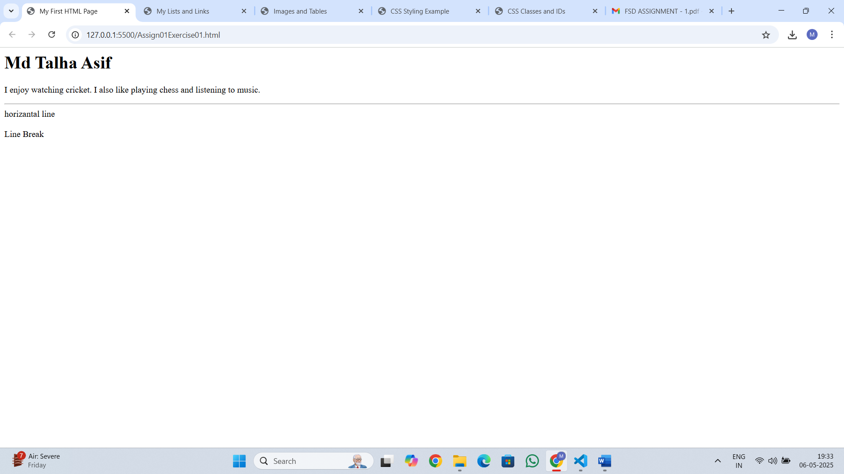

**Exercise 2: Use of Lists and Links**

<html lang="en">

<head>

    <meta charset="UTF-8">

    <meta name="viewport" content="width=device-width, initial-scale=1.0">

    <title>My Lists and Links</title>

</head>

<body>

    <h2>Favorite Fruits (Unordered List)</h2>

    <ul>

        <li>Strawberries</li>

        <li>Mangoes</li>

        <li>Blueberries</li>

    </ul>

    <h2>Top 3 Movies (Ordered List)</h2>

    <ol>

        <li>Avenger infinity wars</li>

        <li>Spiderman</li>

        <li>Batman The Dark Knight</li>

    </ol>

    <h2>Favorite Website</h2>

    <p>Visit my favorite site:

        <a href="https://www.yahoo.com" >Yahoo.com</a>

    </p>

</body>

</html>

**Output**

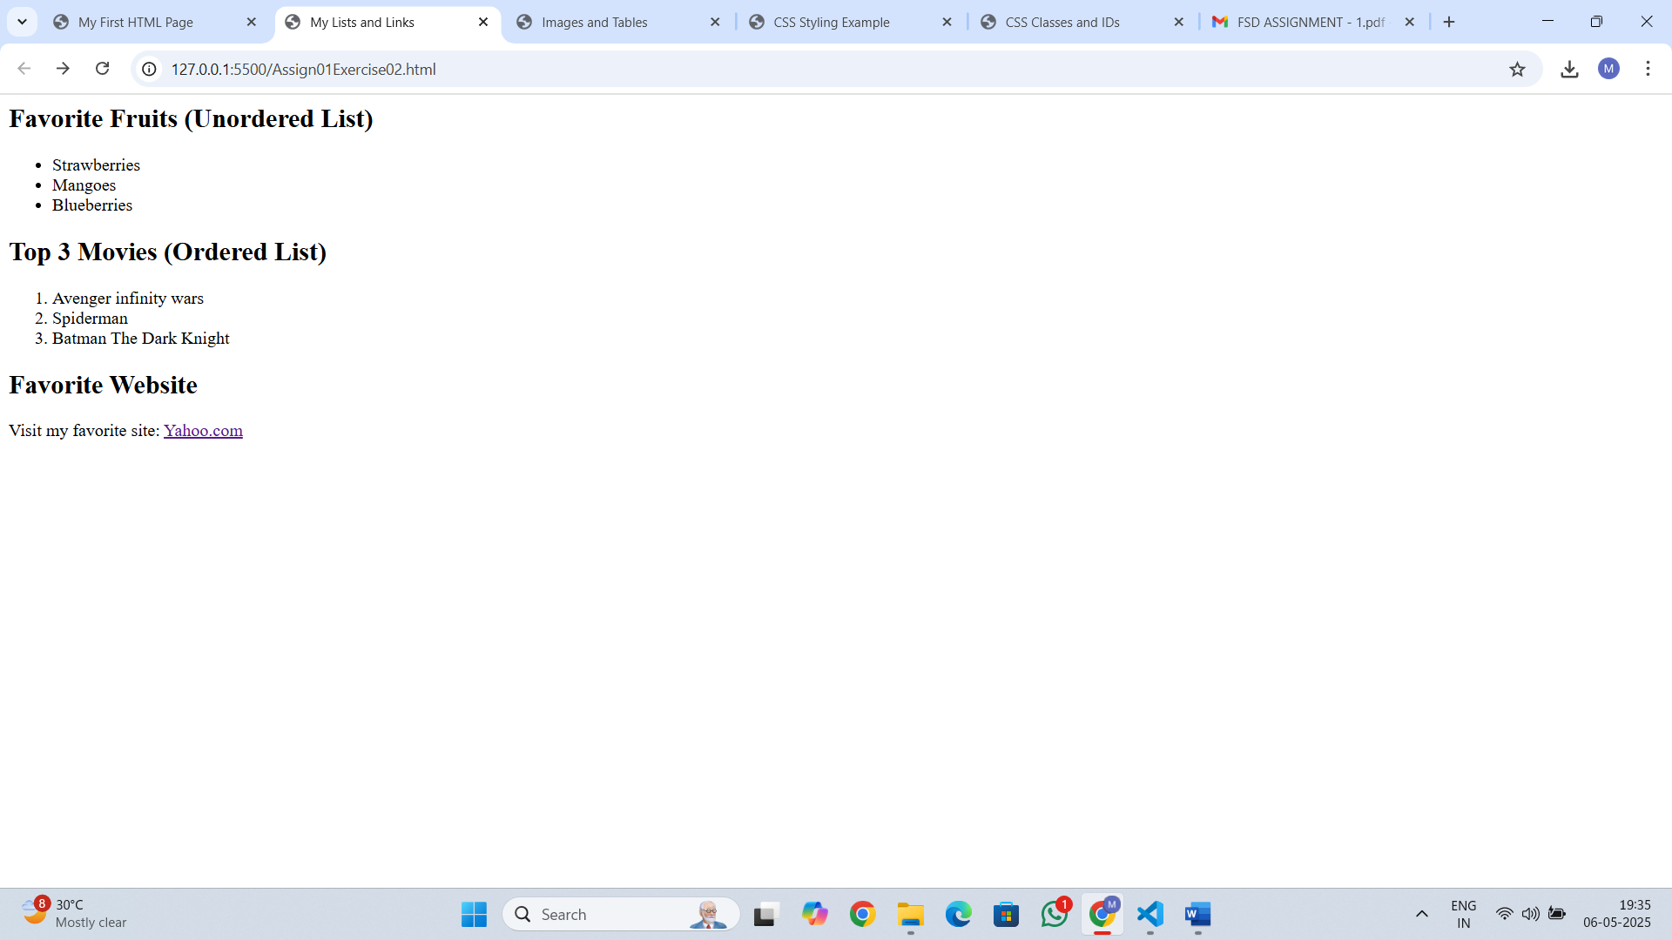

**Exercise 3: Adding Images and Tables**

<html lang="en">

<head>

    <meta charset="UTF-8">

    <meta name="viewport" content="width=device-width, initial-scale=1.0">

    <title>Images and Tables</title>

</head>

<body>

    <h2>Image</h2>

    <img src="img1.jpg">

    <h2>Student Information Table</h2>

    <table border="1">

        <tr>

            <th>Student Name</th>

            <th>Age</th>

            <th>Favorite Subject</th>

        </tr>

        <tr>

            <td>Abhishek</td>

            <td>23</td>

            <td>Math</td>

        </tr>

        <tr>

            <td>Rahul</td>

            <td>24</td>

            <td>English</td>

        </tr>

        <tr>

            <td>Charlie</td>

            <td>25</td>

            <td>Computer Scicence</td>

        </tr>

    </table>

</body>

</html>

**Output**

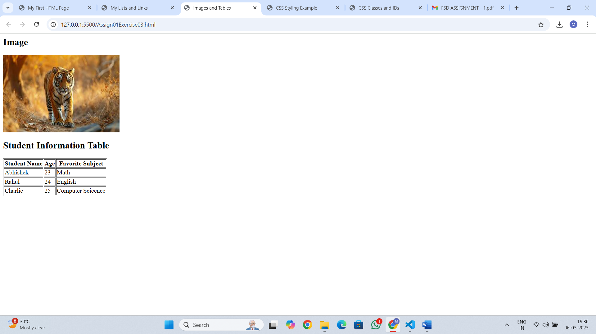

**Exercise 4: Introduction to CSS (Internal CSS)**

<html lang="en">

<head>

    <meta charset="UTF-8">

    <meta name="viewport" content="width=device-width, initial-scale=1.0">

    <title>CSS Styling Example</title>

    <style>

         h1 {

            background-color: lightblue;

            color: darkblue;

            font-size: 30px;

        }

        p {

            font-family: Arial, sans-serif;

            text-align: justify;

        }

    </style>

</head>

<body>

    <h1>Welcome to CSS Styling</h1>

    <p>This paragraph demonstrates how to style text using internal CSS.  Notice the font family and justified alignment.</p>

</body>

</html>

**Output**

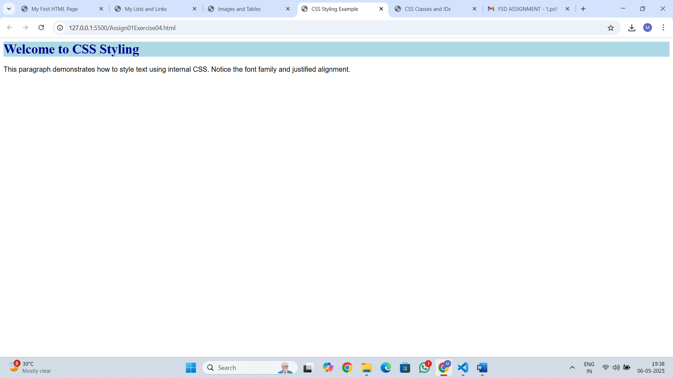

**Exercise 5: CSS Classes and IDs**

<html lang="en">

<head>

    <meta charset="UTF-8">

    <meta name="viewport" content="width=device-width, initial-scale=1.0">

    <title>CSS Classes and IDs</title>

    <style>

        #intro {

            border: 2px solid black;

            padding: 15px;

        }

        .highlight {

            background-color: yellow;

        }

    </style>

</head>

<body>

    <div id="intro">

        <p>This is the intro section. It has a border and padding.</p>

    </div>

    <div class="highlight">

        <p>This is the highlighted section. It has a yellow background.</p>

    </div>

</body>

</html>

**Output**

